|  |  |  |  |
| --- | --- | --- | --- |
|  | 8/19/2015 |  | |
| |  |  | | --- | --- | |  |  | |  |  | |  |  | |  |  | | |  | |
| Game Testing Report  *19/8/2015* | | | |
|  |  | | |  |  |  | | --- | --- | --- | |  |  |  | |  |  |  | |  |  |  | |  |  |  | |  |  |  | |  |  |  | |
|  |  | | LeDinhAn |

Game Testing Report

19/8/2015

# Purpose of the report

The report is to provide information about the progress of the “Ocean Ring Toss” project and about bugs and difficulties that we now encounter.

# Bugs and Difficulties

On 19/8/2015, the game is now ported on Android operating system. However, we now encounter problems. The first problem is that bubble models sometimes do not appear on the screen or are too big after the water gun has been tapped. The second problem is ring-in-pillar checking algorithm. The algorithm is still not stable. Sometimes the game miscount the number of the rings in the two pillars. The third problem is that sometimes the ring is stuck on the pillar. The problems mentioned above are the only problems we are encountering and working on fixing.

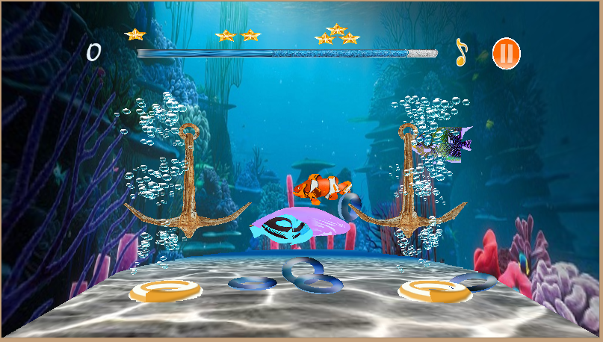

Figure Sample Gameplay scene